Omni Instruments
TCG-240D Remote Monitoring System
User Manual

Short description
TCG240D is a battery powered pulse input data logger with GSM-GPRS interface.
It has 4 digital inputs. The digital inputs can work in OPEN/CLOSE or COUNTER mode.
The status of the device can be periodically saved in the embedded data logger. Any alarm condition can initiate a record in the logger.
TCG240D may periodically send data to a remote server, which makes it suitable for client-server monitoring and control systems.

Features
- Quad-bands connectivity
- Autonomy battery operation
- Sleep mode for extended battery life
- Setup via USB, SMS and HTTP API
- digital inputs with OPEN/CLOSE and counter modes
- 32-bit counters
- Data logger with up to 70000 records
- Periodical HTTP post with current status in XML or JSON file to remote server
- Periodical HTTP post with the last logger data in CSV file to remote server
- HTTP API commands
- Firmware update over USB or GPRS.

Applications
- Smart totalizing
- Remote totalizing of flow and energy meters with pulse outputs.
- Status reporter
- SMS and HTTP Post alerts can be sent to the authorized recipients. The alerts can be triggered in any alarm state.

Specifications
- Physical characteristics
  - Dimensions: 122 x 120 x 55 mm
  - Weight: 410 g (with battery)
  - Mounting: wall
- Environmental limits
  - Operating Temperature: -20 to 50°C
  - Storage Temperature: -25 to 60°C

- Protection
  - Ingress protection: IP65
- Standards and Certifications
  - Safety: EN 60950-1:2006+A11:2009+A1:2010+A12:2011+A2:2013; EN 61010-1:2010
  - EMC: EN 55022:2010, EN 55024:2010, EN 61000-3-2:2014, EN 61000-3-3:2013 EN 301489-1 V1.9.2, EN 301489-7 V1.3.1
  - RFSU: EN 301511 V9.0.2
  - Green: RoHS compliant
- Battery
  - Battery type: non-rechargeable (Li-SOCl2)
  - Voltage: 3.6V
  - Maximum recommended continuous current: >1500 mA
  - Maximum pulse capability: >2500mA
- Cellular interface
  - Standards: GSM/GPRS
  - Bands: 850/900/1800/1900 MHz
  - GPRS multi-slot class: 12, 1~12 configurable
  - GPRS terminal device class: Class B
  - Compliant to GSM Phase 2/2+: Class 4 (2W@850/ 900MHz), Class 1 (1W@1800/1900MHz)
  - SIM card size: Micro
  - Antenna connector: SMA-F
- Digital inputs
  - Isolation: Non isolated
  - Type: Dry contact
  - Maximum input voltage for digital inputs: +5.5VDC
  - Sampling rate: 0.0625, 0.25, 0.5, 1, 2, 3, 4, 5, 6, 10, 15, 20, and 30 seconds
  - Digital filtering time interval (Delay): (0 to 255) x Sampling rate
- Data logger
  - Capacity: Up to 70000 records
- Internal FLASH memory
  - Settings segment endurance: 100 000 cycles (Every setting change is a memory cycle). Data logger segment endurance: 100 000 cycles of 70000 records.
  - Update segment endurance: 100 000 cycles (updates).

Installation
This device must be installed by qualified personnel. The installation consists of mounting the device, connecting to the GSM network, connecting inputs and outputs, providing power, and configuring via a web browser.
Attention! Before installing the SIM card in the card slot, please ensure that the PIN code is disabled.

Mounting
TCG240D should be mounted in a clean and dry location on a nonflammable surface. Ventilation is recommended for installations where the ambient air temperature is expected to be high.
Mount the device to a wall by using a minimum of two plastic wall plugs 8x60mm and two screws 6x70mm. See Appendix C, fig. 1 for mechanical details.
Maintain spacing between adjacent equipment. Allow 50 mm of space on all sides, as shown in fig.2 in Appendix C, this provides ventilation and electrical isolation.

Connectors
Attention! Disconnect power supply before wiring.
The correct wiring procedure is as follows:
- Make sure battery is taken out
- Make wiring connections to the terminals
- Insert the battery

It is recommended to test and configure TCG240D without any controlled device.
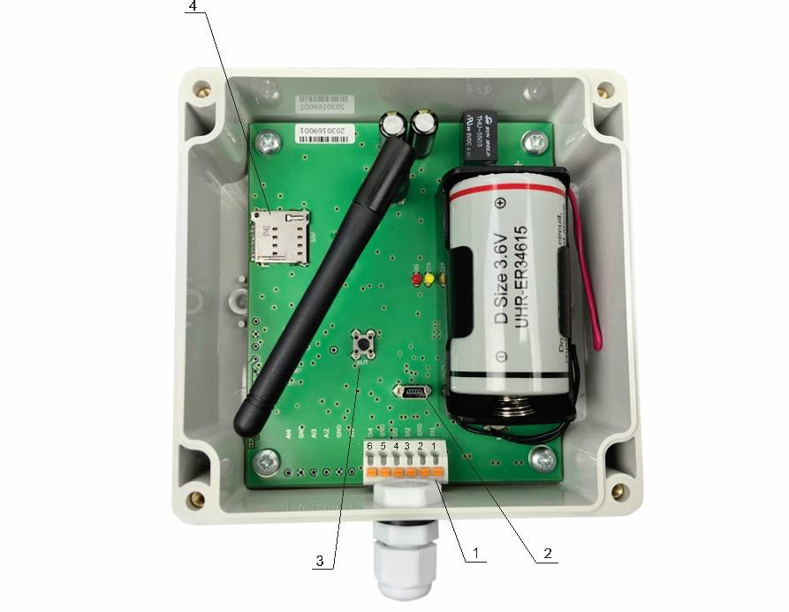Make sure that wires are properly attached to the terminals and that the terminals are tightened. Not proper wiring and configuration can cause permanent damage of TCG240D or the equipment to which it is connected or both. Inputs and outputs locations are shown below:

Connector 1
- Connector 1
  - Pin 1 - Digital input 1 (DI1)
  - Pin 2 - Ground (GND)
  - Pin 3 – Digital input 2 (DI2)
  - Pin 4 - Digital input 3 (DI3)
  - Pin 5 - Ground (GND)
  - Pin 6 - Digital input 4 (DI4)
- Connector 2 – mini USB
- Connector 3 – Reset button
- Connector 4 – SIM card holder

Digital inputs connection
Attention! Digital inputs are NOT galvanic isolated.
The TCG240D digital inputs can be used in two modes – OPEN/CLOSE and COUNTER.
In OPEN/CLOSE mode digital inputs can be used to monitor the state of a discrete device – door contact switch, push button, PIR detector etc.
In the COUNTER mode the digital inputs can be used to monitor and totalizing of smart meters.
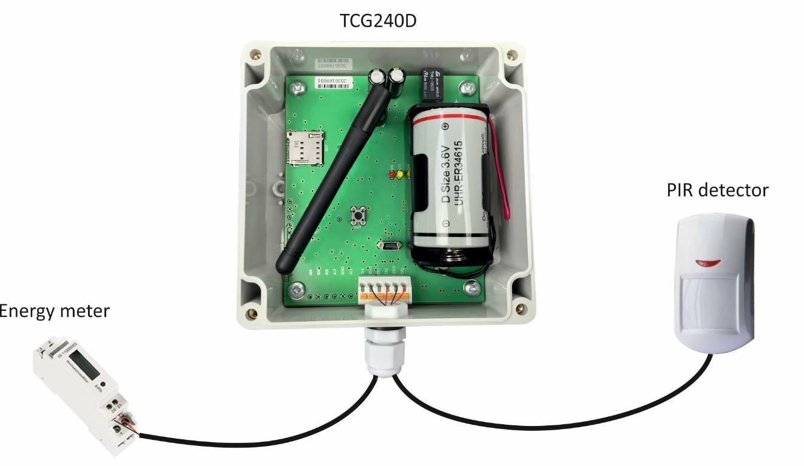

The maximum cable length for a digital input should be up to 30 meters.

LED indicators
LED indicators show the status of the controller:
- SIG (red) – indicates the status of the device together with STA
- STA (yellow) – indicates the status of the device together with SIG.

The following states are displayed:
- Controller initialization – after power-on and firmware update SIG and STA turn ON for a second, after this turn OFF for another second.

- Searching for GSM network – after initialization, SIG is OFF, STA flashes (flash length – 200ms)
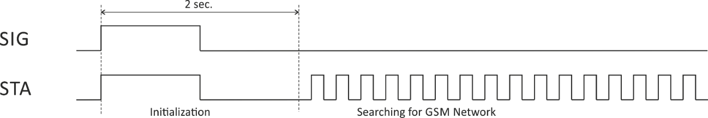

- Connected to GSM network – after successful connection to a mobile network, STA shows the type of connection, while SIG shows the signal strength.
STA flashes ones for 200mS in period of 2S – there is GSM connection only.

STA flashes twice for 200mS in a period of 2S – there is GSM and GPRS connection.

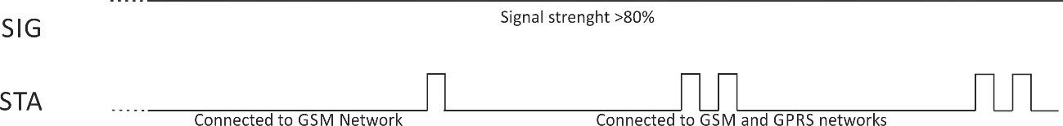

At the same time SIG has 5 states:
SIG flashes 1 time in period of 2S – signal strength is between 0 and 20%;
SIG flashes 2 times in period of 2S – signal strength is between 21 and 40%;
SIG flashes 3 times in period of 2S – signal strength is between 41 and 60%;
SIG flashes 4 times in period of 2S – signal strength is between 61 and 80%;
SIG is solid ON – signal strength is between 81 and 100%;

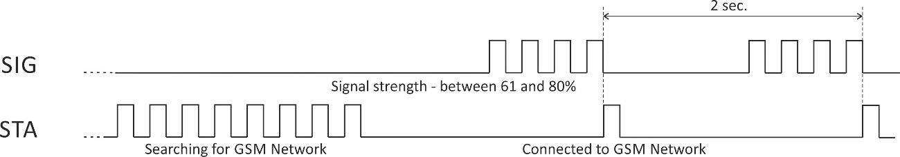

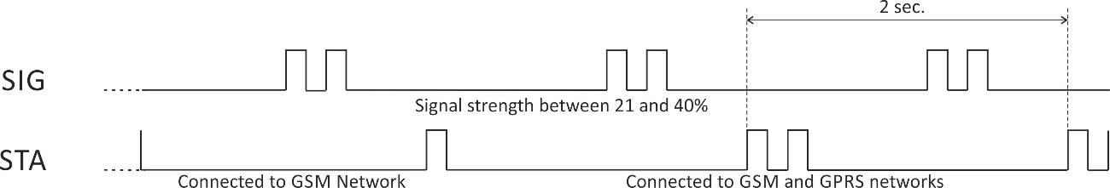

- Error message – in case of error after initialization, SIG will stay solid OFF, STA will flash showing the type of error.
STA flashes ones for 1S – master phone number is not set.
STA flashes permanently for 1S in a period of 2S – permanent hardware error.

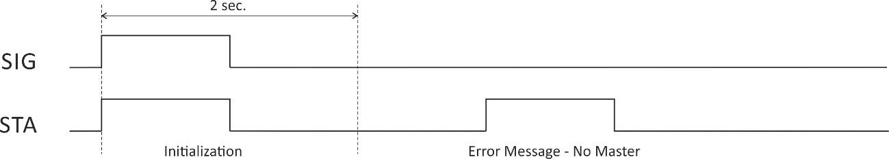

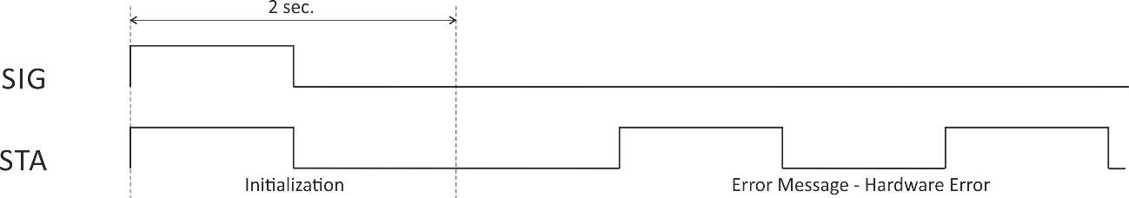

Initial setup via USB
The initial setup of TCG240D controller is done with a computer running Windows 7 or newer Microsoft Windows operating system. After power-up, the controller should be connected to the computer with USB cable. Once the USB cable is connected, the operating system automatically starts to install the drivers for the communication with the device. The following message appears:

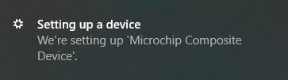

The following drivers will be installed:
- Microchip composite device
- USB serial port driver

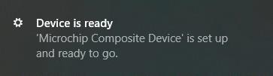

If for some reason the USB serial port driver cannot be installed automatically, it must be installed manually. The driver can be downloaded from the TCG240D product page at www.teracomsystems.com. After successful driver installation, the device will be recognized as Mass storage, the following window appears on the screen:

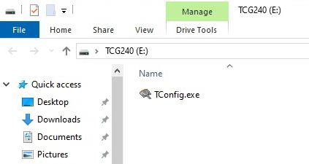

The only file stored on the mass storage is a tool called “TConfig”. This tool enables the communication between the TCG240D and PC. After starting the TConfig tool, the following program will appear:

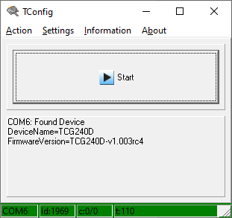

Pressing the “Start” button will start your web browser and display the Monitoring page of your TCG240D controller.

The other menu functions are as follows:
- Action tab
  - Start – will start the web browser
  - Check Device – refreshes the display of the device settings

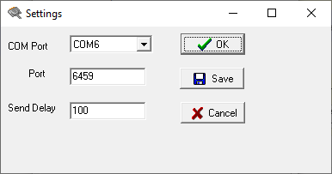
- Settings Tab
  - Com Port – manually select the com port for the logger to use
  - Port – manually set the web port to use for the monitor page
  - Send Delay – manually set the send delay

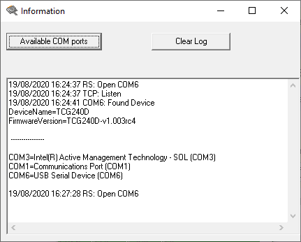

- Information – displays settings log and available com ports to use

- About – displays software information such as version and copyright.

Monitoring page
Monitoring page displays the current state of TCG240D.
The Monitoring page is automatically refreshed every second.
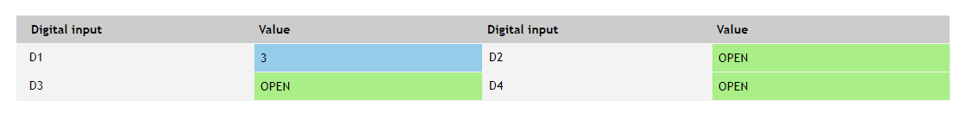
Digital inputs can be used in discrete mode for monitoring the state of dry contact outputs devices – motion sensor, door contact, relay contact, alarm output etc.
Digital inputs can be used in counter mode for smart metering totalization.

Setup

SMS

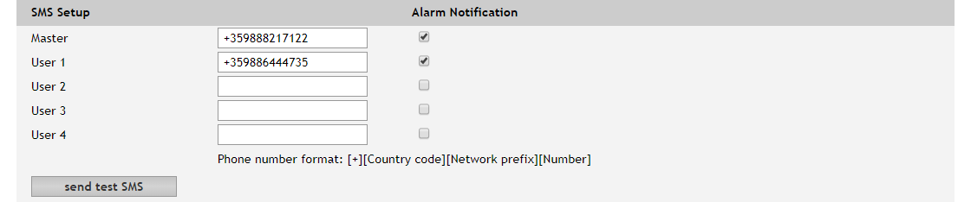
SMS Alarm recipients can be set in this section.
The “Master” has special rights to change the device settings using SMS commands.
The remaining 4 recipients can receive SMS messages if any of the parameters is in alarm state. To receive SMS messages, the number should be enabled in the checkbox “Alarm Notification”. These 4 recipients can also ask by SMS for parameter state/value.
By pressing “send test SMS” button all SMS recipients will receive a test SMS. All commands, their syntax, and answers are described in “Setup via SMS”.

Periodic check for SMS

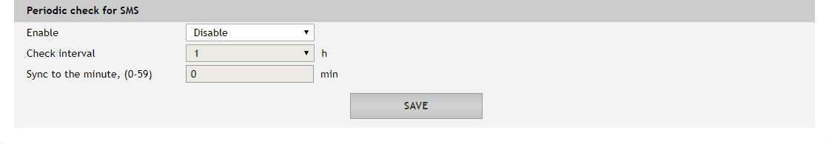
To save the power, incoming SMS are checked on “Check interval” if this functionality is enabled.

Input

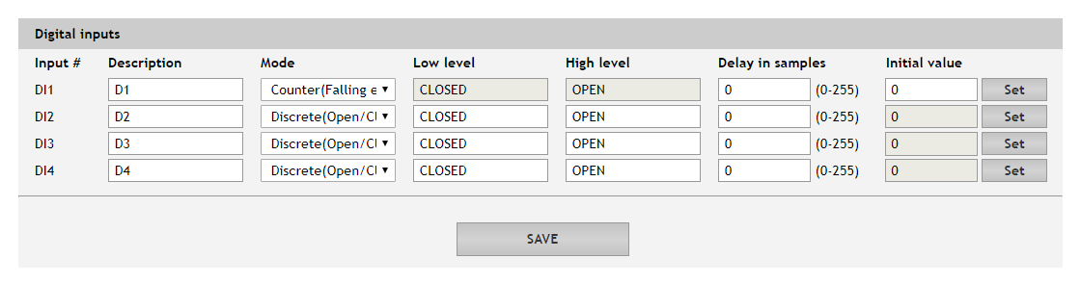
For every digital input, a description, up to 20 symbols can be set. These descriptions will appear on the monitoring page, alarms page and XML/JSON data.
Every digital input can be set OPEN/CLOSE or COUNTER mode.
There are delays in samples for digital input change. By default, delays are zero. The delay is calculated in the sample/wake-up interval. The delay can be used for filtering.

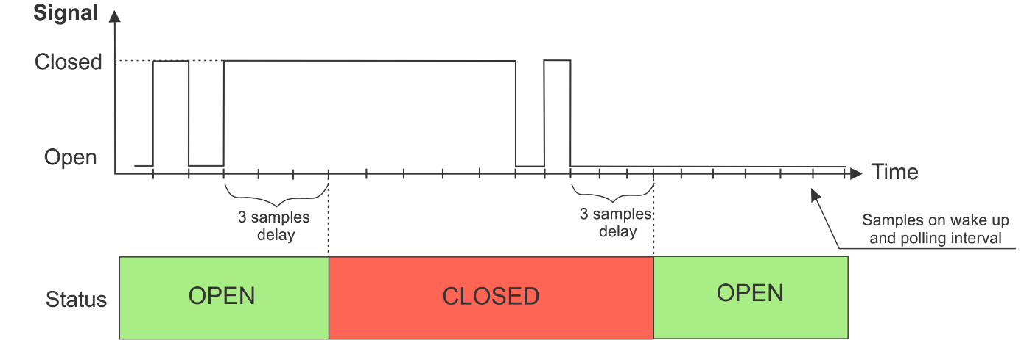
For the Counter mode, there is a possibility for setting up of the counter initial value.

Alarms

Alarms

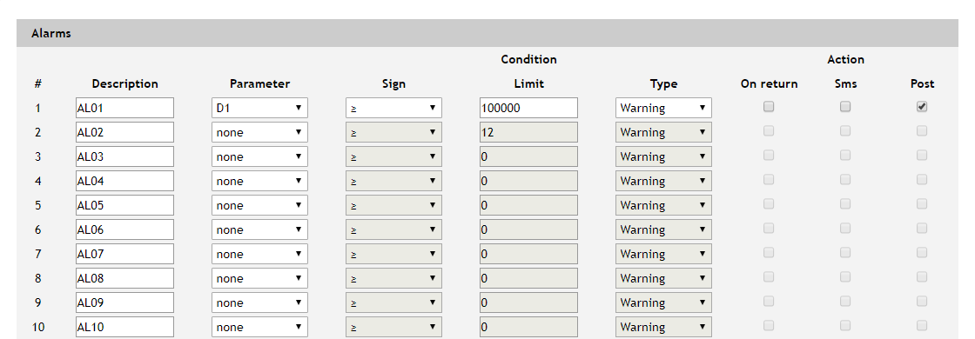
For every alarm, a description of up to 20 symbols can be set. Digital inputs in COUNTER mode only can be set.
There are four types of alarms – Warning, Minor, Major and Critical.
When the alarm is activated 2 independent alert actions are possible – SMS and Post (HTTP post with XML/JSON file). Each alarm notification method is activated by a checkbox.
In the time when the input is in an alarm state, the appropriate input will be coloured in red on the Monitoring page.

Discrete alarms

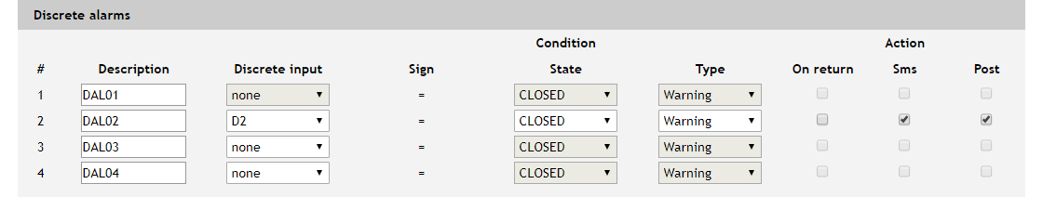
To assign a digital input to this alarm, it must be preset in Discrete (OPEN/CLOSE) mode in the Setup / Input page.
The alarm state can be set for every alarm.
There are four types of alarms – Warning, Minor, Major and Critical. For every discrete alarm, a description of up to 20 symbols can be set.
When the discrete alarm is activated, 2 independent alert actions are possible – SMS and Post (HTTP post with XML/JSON file). Each alarm notification method is activated by a checkbox.

System
The page for some general settings.

System status

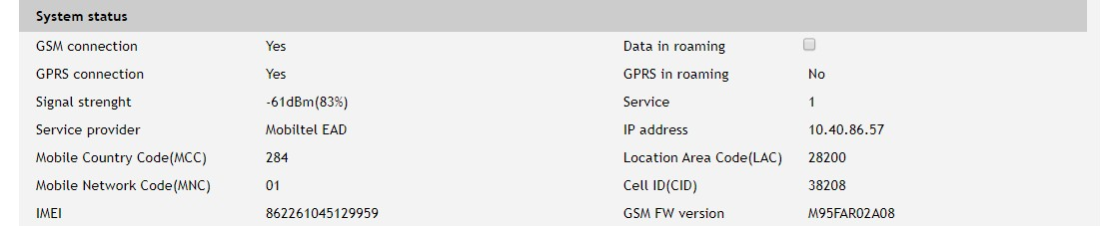
There is information about the general status of the controller here.
The only possible setting here is “Data in roaming” checkbox. By default, it is disabled to avoid extra charges for data transfer in roaming.
If you are using another operator's card, you must activate “Data in roaming”. Otherwise, you will not be able to use all GPRS services – emails, HTTP Post, NTP, etc.

GPRS setup

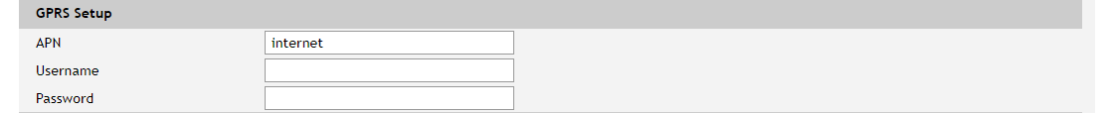
To set the GPRS connection it is necessary to enter the APN (Access Point Name). This setting can be different for each GSM service provider. By default, it is set to “internet”. Some providers may also require username and password.

General setup

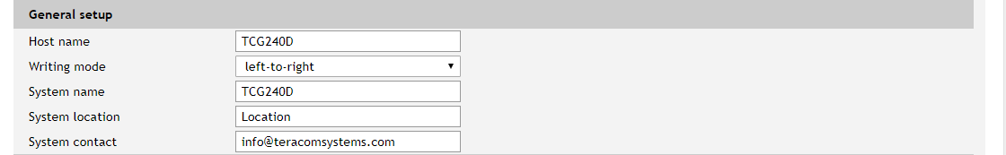
The section for some general settings.
Writing mode change the alignment in the WEB interface and SMS.
Hostname, System name, System location, and System contact are sent in XML/JSON files and can be used for flexible identification of the device.

Power saving setup

In this section wake-up (polling) interval can be set. Possible options are 0.0625, 0.25, 0.5, 1, 2, 3, 4, 5, 6, 10, 15, 20, and 30 seconds.
As higher is this parameter as longer is the battery life. Of course, the reaction of the device gets slower.

Device restart
In this section there are tools for full device restart and reset to factory default settings.

Time
For automatic clock synchronization, the controller supports NTP (Network Time Protocol) and all necessary parameters for automatic synchronization are available in this section.
The clock synchronization is made on “Interval” time. If the attempt was not successful, the next synchronization will be on “If not found” time.

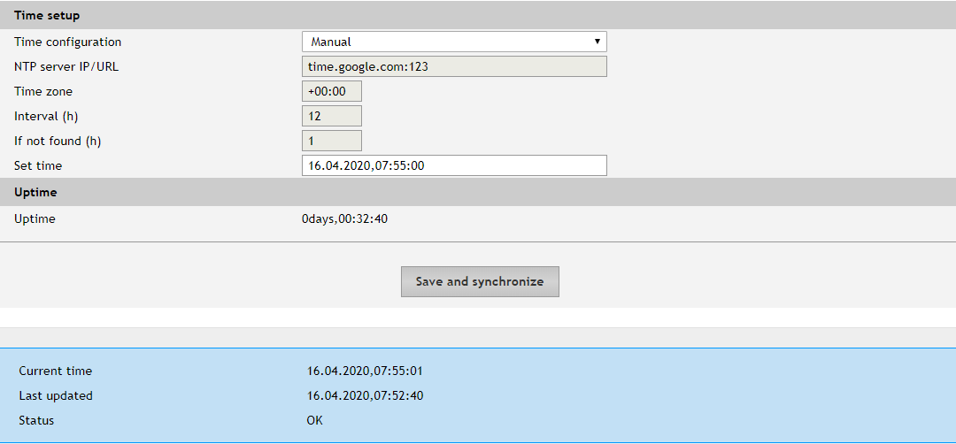
Pressing the “Save and synchronize” button initiates time synchronization. The information for “Status” in the blue box is very useful for the availability of time server and Internet at all.
The current system time is sent in XML/JSON file when HTTP Post is enabled
By default, NTP server – time.google.com, port - 123, Timezone +00:00 and interval of 12 hours.

Services

Data logger
The logger works in three modes – Time, Alarm and Time&Alarm. The mode specifies what initiates a record in the logger’s memory.

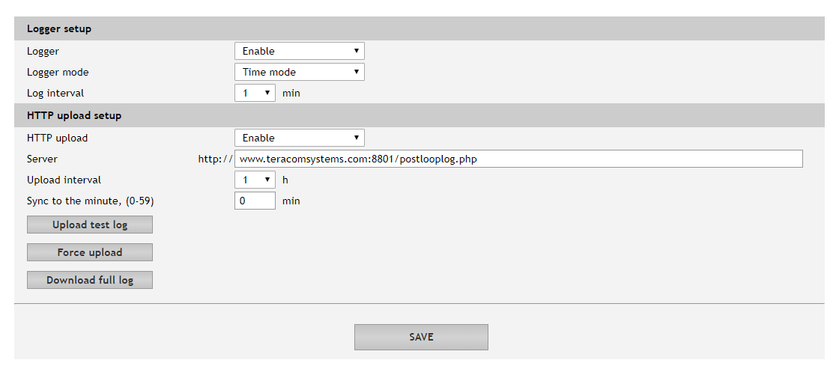
In Time mode, records are made periodically on “Log interval” time. In Alarm mode, records are made on every alarm condition. In Time&Alarm mode, a mix of both conditions for records is used.
The log interval determines the time between two log entries. It is good to remember that by reducing the log interval, we increase the resolution, but we also reduce the past period for which we have records.
There are two ways to reach the logger records:
- periodical upload the last unsent records to the dedicated HTTP server.
The records are uploaded in CSV file format. The period of the upload can be chosen from the menu between 1 and 24 hours. If you enable this service, take care of the real-time clock (NTP service).
The HTTP server for upload can be domain or IP address but take care about DNS settings. “Sync time” is a moment in the day when a period of upload is synchronized.
Example:
Current time is 19:31, Upload period is 3 hours and Sync time is 9:00.
To synchronize the logger to 9:00 it means that time for uploads will be: 09:00, 12:00, 15:00, 18:00, 21:00, 24:00, 03:00 and 06:00. The first upload, after enabling the logger in 19:31, will
be in 21:00.
The button “Force upload” initiates upload recorded information between previous periodical upload and now.
By default, the logger is disabled.
More about the logger can be found in the Data logger section.

HTTP Post
HTTP Post is used for periodically upload an XML/JSON file to HTTP server by HTTP requests (POST method). The XML/JSON file contains current status of all monitored parameters and extra system information. The file format is chosen from the drop-down menu.
The HTTP server can be addressed either by domain name or IP address.
The period of the upload can be chosen from the menu between 1 and 24 hours. This parameter can be changed remotely also by HTTP API. The "Period" determines at what time the control software receives up-to-date information from TCG240D and can, therefore, make changes to some of the parameters. The shorter is "Period", the closer to the real-time operation is the system. On the other hand, as shorter is the "Period" as higher is the data traffic through the mobile network and the power consumption.
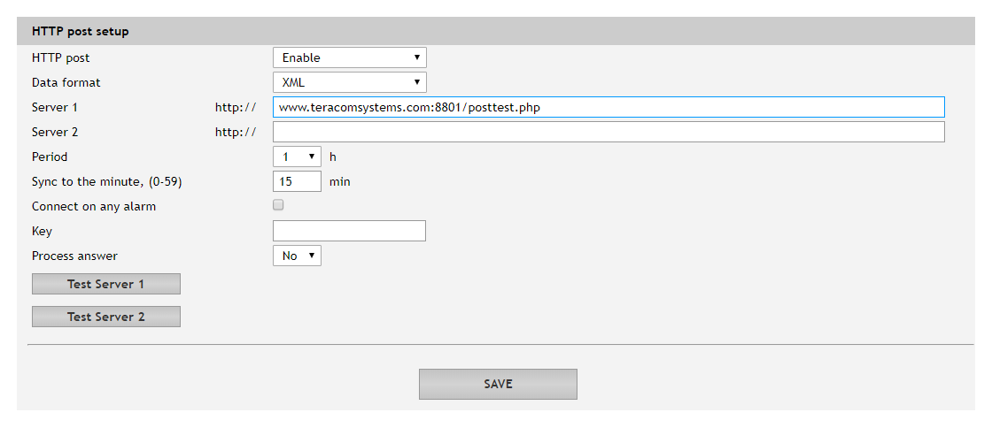
If the checkbox “Connect on any alarm” is selected, the HTTP Post request will be sent in an alarm condition.
The “Key” field is user defined. Its value is sent in XML/JSON file and can be used for device identification.
If “Process Answer” option is enabled, TCG240D will execute the commands, sent by the remote server as an answer to HTTP Post.

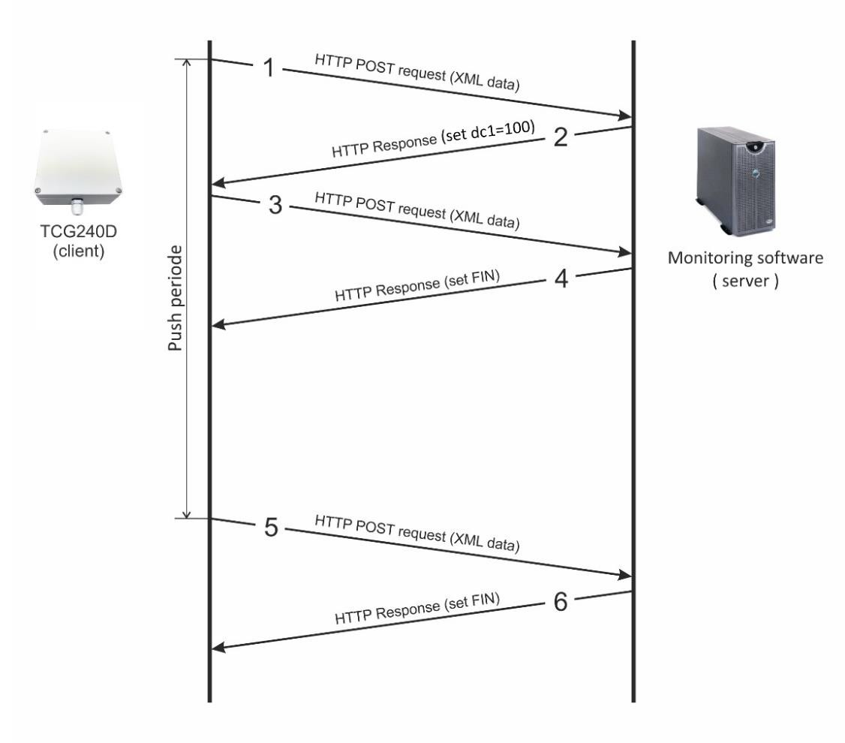
Step 1 - HTTP POST request with XML data is sent to the remote server
Step 2 - the server responds with HTTP response message, which contains “set dc1=100” command as a brief text in the message body
Step 3 - new HTTP POST request is sent to the server to confirm the reception of the “set dc1=100” command.
Step 4 - the server sends new HTTP response, which includes “set FIN” in the message body. This indicates that there are no pending commands and the session can be closed.
Step 5 - when the Push period timer expires, TCG240D sends new HTTP POST request to the server
Step 6 – the server answers with “set FIN” – there is no pending commands and the session can be closed.
HTTP Post command format: set yyy=xxx
Where:
yyy is the command; xxx is the parameter.
TCG240 supports following HTTP commands, they are case sensitive:

Command | Description
dmn=x | Digital inputs mode  n is 1-:-4,  x is 0-:-3, where  0 for Discrete (Open/Closed) mode 1 for Counter(Rising edge)  2 for Counter(Falling edge) 3 for Counter(Both edges)

dsamn=xxxx | Delay in samples for digital inputs  where n is 1-:-4 , xxxx is between 0 and 255
dcn=xxxx | Set initial value for counter,  n is 1-:-4, xxxx is between 0 and 1 999 999
psseconds=x | Set wakeup and polling interval, where x is 0 for 0.0625s  - for 0.25s  - for 0.5s  - for 1s  - for 2s  - for 3s  - for 4s  - for 5s  - for 6s  - for 10s  - for 15s  - for 20s  - for 30s
Logen=x | Enable/disable logger – 0 disable, 1 enable
Logmode=x | Logger mode – 0 Time, 1 Alarm, 2 Time&Alarm
logint=x | Logger interval in minutes, where x is 1 for 1 min  - for 2 min  - for 3 min  - for 4 min  - for 5 min  - for 6 min  10 for 10 min  15 for 15 min  20 for 20 min  30 for 30 min  60 for 60 min
httpen=x | Logger HTTP upload – 0 disable, 1 enable
httpserver=yyy | URL for HTTP Upload to Server , where yyy is a full path to php file. Example:  httpserver= www.teracomsystems.com:8801/postlog.php
httpint_h=x | HTTP Upload interval in hours, where x is 1 for 1 hour  - for 2 hours  - for 3 hours  6 for 6 hours  8 for 8 hours  12 for 12 hours  24 for 24 hours
httpint_m=xx | HTTP Upload sync to the minute, where xx is between 0 and 59
pmet=x | Enable/disable HTTP Post - 0 disable, 1 enable
dataf=x | Data format XML/JSON for HHTP Post – 0 XML, 1 JSON
purl=yyy | URL for HTTP Post to Server 1, where yyy is a full path to php file. Example:

 | purl= www.teracomsystems.com:8801/posttest.php
purl2=yyy | URL for HTTP Post to Server 2, where yyy is a full path to php file Example:  purl= www.teracomsystems.com:8801/posttest2.php
postint_h=x | HTTP Post period in hours, where x is 1 for 1 hour  - for 2 hours  - for 3 hours  6 for 6 hours  8 for 8 hours  12 for 12 hours  24 for 24 hours
postint_m=xx | HTTP Post sync to the minute, where xx is between 0 and 59
dk=xxx | HTTP Post key – xxx is up to 17 characters
pans=x | HTTP Post process answer – 0 No, 1 Yes
FIN | Terminate session  (it makes sense only for HTTP Post)
The typical monitoring application is shown in the picture below:

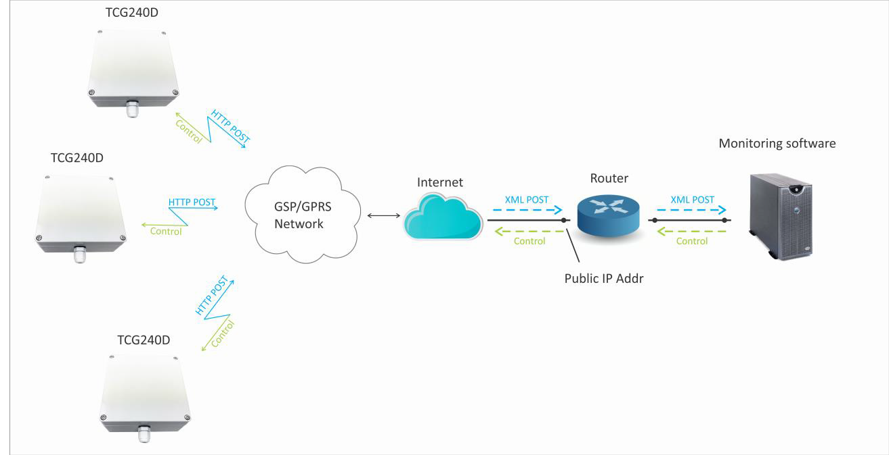
The structure of Status.xml is shown in Appendix A, while Status.json is shown in Appendix B.

Administration

Backup/Restore

TCG240D supports backup and restore of all user setting. All settings are saved in XML backup file. This file can be used after this for restore on many devices. This is very useful for multiplying similar settings to a batch of controllers

Firmware update

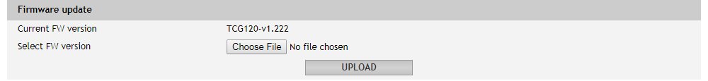
TCG240D supports firmware update over the WEB interface.
It is very simple. Download the latest firmware from www.teracomsystems.com, choose the file and press “upload” button.
Attention! Don’t turn off the power supply during the update. Turning off the power supply will damage the device.

Setup via SMS
TCG240D supports SMS commands for parameters change and status reports, including firmware update over the air. The commands will be executed if they are sent from previous set 5 phone number. Some of the commands require Master user rights.
Below is a list of the supported SMS commands. Note that the underscore character “˽” must be replaced by one space character.
  - Set new master number
Rights: Master
Syntax: set˽master˽<number> Where
<number> is a mobile number in the international format

Example
Command: set master +359885885885 Answer: You are the new master!
  - Set SMS users numbers - add/delete SMS users
Rights: Master
Syntax: set˽sms˽user˽<user>:<number>
Where
<number> is a mobile number in the international format
<user> can be u1, u2, u3 or u4

Example
Command: set sms user u1:+359885887766 Answer: u1:+359885887766,u2,u3,u4
Command: set sms user u2:+359885999888
Answer: u1:+359885887766, u2:+359885999888,u3,u4
Command: set sms user u1:
Answer: u1, u2:+359885999888,u3,u4
  - Display SMS users numbers
Rights: Master, Users
Syntax: display˽sms˽users

Example
Command: display sms users
Answer: m:+359885885885,u1:+359885887766,u2:+359885999888,u3,u4
  - Status of system - requests main parameters of the device
Rights: Master, Users Syntax:status˽system

Example
Command: status system
Answer: 27.06.2017,16:09:06,gprs=y,ss=80%,fw=1.00
  - Status of parameter - requests status of digital input (di)
Rights: Master, Users
Syntax: status˽<param> Where
<param> is one of: di1, di2, di3, di4
Example
Command: status di1
Answer: di1(Garage_door)=CLOSED
  - Initial value – sets initial value for digital input counter
Rights: Master
Syntax: set dcn=<val>
Where n is 1-:-4, <val> - initial value Example set digital input 1 counter with 1000 Command: set dc1=1000
Answer: dc1=1000
  - Set wake up interval – sets wake up and polling interval
Rights: Master
Syntax: set˽pssec=<time>
Where <time> is one of 0.0625, 0.25, 0.5, 1, 2, 3, 4, 5, 6, 10, 15, 20, 30 in
seconds
Example set wake up and polling interval 0.5 sec Command: set˽pssec=0.5
Answer: pssec=0.5
  - Set logger interval – sets logger interval
Rights: Master
Syntax: set logint=<int> Where
<int> is one of 1, 2, 3, 4, 5, 6, 10, 15, 20, 30, 60
Example set log interval 5 min Command: set˽logint=5
Answer: logint=5
  - HTTP upload interval – sets HTTP upload interval Rights: Master
Syntax: set upint=<hh:mm>
Where
<hh:mm> - hh – hour, mm - minutes Example set upload interval 2 hours and 15 min Command: set˽upint=02:15
Answer: upint=02:15
  - HTTP upload on – sets HTTP upload on Rights: Master
Syntax: set upload=on

Example
Command: set˽upload=on
Answer: upload=on,period=01:15
  - HTTP upload off – sets HTTP upload off Rights: Master
Syntax: set upload=off

Example
Command: set˽upload=off
Answer: upload=off,period=01:15
  - HTTP upload URL – sets URL for HTTP upload Rights: Master
Syntax: set˽upurl=<link>
Where
<link> is the address of remote server (domain or IP)
Example
Command: set upurl=www.teracomsystems.com:8801/posttestlog.php Answer: upurl=www.teracomsystems.com:8801/posttestlog.php,upload=on,
period=01:15
  - Status upload URL – status URL’s for HTTP upload Rights: Master, User
Syntax: status˽upurl

Example
Command: status upurl
Answer: upurl=www.teracomsystems.com:8801/posttestlog.php, upload=on,period=01:00
  - Post URL – sets URL for HTTP Post Rights: Master
Syntax: set˽purl=<link> or set˽purl2=<link>
Where
<link> is the address of remote server (domain or IP)
Example
Command: set purl=www.teracomsystems.com:8801/posttest.php
Answer: purl=www.teracomsystems.com:8801/posttest.php,post=on, period=01:00 Command: set purl2=www.teracomsystems.com:8802/posttest.php
Answer: purl2=www.teracomsystems.com:8802/posttest.php,post=on, period=01:00
  - Status URL – status URL’s for HTTP Post Rights: Master, User
Syntax: status˽purl or status˽purl2

Example
Command: status purl
Answer: purl=www.teracomsystems.com:8801/posttest.php, post=on,period=01:00 Command: status purl2
Answer: purl2=www.teracomsystems.com:8802/posttest.php, post=on,period=01:00
  - Post period – sets HTTP Post period
Syntax: set˽pint=<hh:mm> Where
<hh:mm> - hh – hours, mm - minutes Example set post interval on 2 hours and 30 min Command: set pint=02:30
Answer: postint=02:30
  - Post on – sets HTTP Post on
Rights: Master
Syntax: set˽post=on

Example
Command: set post=on
Answer: post=on,period=02:30
  - Post off – sets HTTP Post off
Rights: Master
Syntax: set post=off

Example
Command: set post=off
Answer: post=off,period=02:30
  - Set a time server
Rights: Master Syntax:set˽ts=url:port

Example
Command: set ts=time.google.com:123 Answer: ts=time.google.com:123,tz=+02:00
  - Set a time zone
Rights: Master
Syntax: set˽tz=±hh:mm

Example
Command: set tz=+03:00
Answer: ts=time.google.com:123,tz=+03:00
  - Restart – restarts the device
Rights: Master Syntax:restart

Example
Command: restart
Answer: Device is restarting!
  - Send test SMS – a message for sending a test SMS to the authorized users
Rights: Master
Syntax: test˽sms

Example
Command: test sms
Answer: This is a test SMS!
Rights: Master
Syntax: update˽<URL> Where
<URL> is a valid URL to public server, pointing update (.cod) file

Example
Command: update www.teracomsystems.com/docs/TCG140-v1.000-P-S.cod Answer 1: Downloading firmware...
Answer 2: Firmware file downloaded. Updating...

Following answers are also possible in different situations: Answer: File corrupt or wrong version!
Answer: Can't connect to server! Answer: Download time out!
Answer: GPRS is not connected! Answer: Connection lost!
Answer: Response timeout! Answer: Socket error!

Firmware update
TCG240D supports firmware update over the WEB interface and over the air. For firmware update over the WEB interface please see 7.4.2. FW update.
For firmware update over the air (GPRS) please follow the steps below:
  - Upload the update file (.cod extension) on public HTTP server ;
  - Send firmware update command (the syntax of the SMS message is described in 8. Setup via SMS).
Please note that only the Master can send this message.
The firmware will be downloaded and verified. The download via GPRS takes around 3 minutes. If the file is correct, the Master will receive confirmation SMS message. The update procedure takes around 2 minutes. Once the firmware update is complete (about 5 minutes), TCG240D will restart.
Attention! Don’t turn off the power supply during the update. Turning off the power supply will damage the device.

Factory default settings
TCG240D can be restored to its original factory default settings, following the steps below:
  - Remove the battery;
  - Press and hold the RESET button then apply the battery;
  - STA and SIG LEDs will turn ON;
  - Release the RESET button.
The controller will restore its default settings.

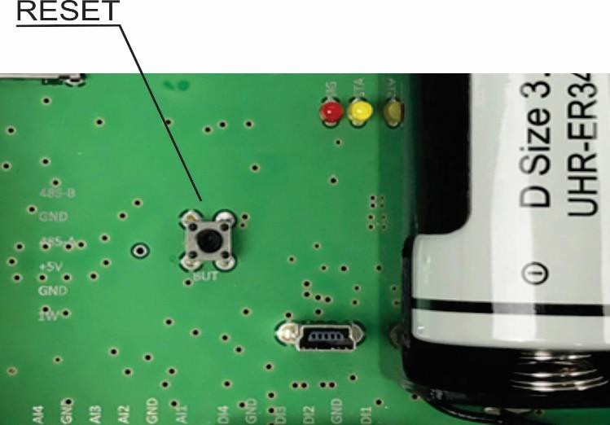

Environment information
This equipment is intended for use in a Pollution Degree 2 environment, at altitudes up to 2000 meters. When the controller is a part of a system, the other elements of the system shall comply with the EMC requirements and shall be intended for use in the same ambient conditions.

Safety
This device must not be used for medical, life-saving purposes or for any purpose where its failure could cause serious injury or the loss of life.
To reduce the risk of fire, only flexible stranded wire, with cross section 0.5mm² or larger for wiring of digital and analog inputs and relay output of the device should be used.
To avoid electric shock and fire hazard, do not expose this product to liquids, rain, or moisture. Objects filled with liquids, such as vases, should not be placed on this device.
There is a risk of overheating (damage) of the controller, if recommended free spaces to adjacent devices are not ensured. The joint part with external component shall have space for attachment/removal of the cable after installation.
Teracom does not guarantee successful operation of the product if the product was used under conditions deviating from the product specifications.

Maintenance
Upon completion of any service or repairs to the device or once per year, safety check must be performed to determine that this product is in proper operating condition. Clean the device only with dry cloth. Do not use a liquid cleaner or an aerosol cleaner. Do not use a magnetic/static cleaning device (dust remover) or any kind of abrasive materials to clean the device.
Appendix A
Structure of Status.xml file:
<Monitor>
<DeviceInfo>
<DeviceName>TCG240</DeviceName>
<HostName>TCG240D</HostName>
<ID>862261045129959</ID>
<FwVer>TCG240D-v1.000</FwVer>
<MnfInfo>www.teracomsystems.com</MnfInfo>
<SysContact>info@teracomsystems.com</SysContact>
<SysName>TCG240D</SysName>
<SysLocation>Location</SysLocation>
</DeviceInfo>
<DI>
</DI>
<DI1>
<description>D1</description>
<value>3</value>
<valuebin/>
<mode>2</mode>
<resetcount>0</resetcount>
<alarmState/>
<alarmbin>1</alarmbin>
<alarm>Normal</alarm>
</DI1>
<DI2>
<description>D2</description>
<value>OPEN</value>
<valuebin>1</valuebin>
<mode>0</mode>
<resetcount>0</resetcount>
<alarmState>CLOSED</alarmState>
<alarmbin>0</alarmbin>
<alarm/>
</DI2>
<DI3>
<description>D3</description>
<value>OPEN</value>
<valuebin>1</valuebin>
<mode>0</mode>
<resetcount>0</resetcount>
<alarmState>CLOSED</alarmState>
<alarmbin>0</alarmbin>
<alarm/>
</DI3>
<DI4>
<description>D4</description>
<value>OPEN</value>
<valuebin>1</valuebin>
<mode>0</mode>
<resetcount>0</resetcount>
<alarmState>CLOSED</alarmState>
<alarmbin>1</alarmbin>
<alarm>Normal</alarm>
</DI4>
<HTTPPost>
<Key/>
<PostPeriod>1</PostPeriod>
<SyncM>15</SyncM>
</HTTPPost>
<Sys>
<signalpercent>83</signalpercent>
<hwerr/>
<HighAlarmbin>1</HighAlarmbin>
<HighAlarm>Normal</HighAlarm>
</Sys>
<Time>
<Date>16.04.2020</Date>
<Time>08:00:52</Time>
</Time>
</Monitor>

The JSON file structure:
{
Appendix B
"Monitor": {
"DeviceInfo": {
"DeviceName": "TCG240",
"HostName": "TCG240D",
"ID": "862261045129959",
"FwVer": "TCG240D-v1.000",
"MnfInfo": "www.teracomsystems.com",
"SysContact": "info@teracomsystems.com",
"SysName": "TCG240D",
"SysLocation": "Location"
},
"DI": {
"DI1": {
"description": "D1",
"value": "3",
"valuebin": "",
"mode": "2",
"resetcount": "0",
"alarmState": "",
"alarmbin":"1",
"alarm": "Normal"
},
"DI2": {
"description": "D2",
"value": "OPEN",
"valuebin": "1",
"mode": "0",
"resetcount": "0",
"alarmState": "CLOSED",
"alarmbin":"0",
"alarm": ""
},
"DI3": {
"description": "D3",
"value": "OPEN",
"valuebin": "1",
"mode": "0",
"resetcount": "0",
"alarmState": "CLOSED",
"alarmbin":"0",
"alarm": ""
},
"DI4": {
"description": "D4",
"value": "OPEN",
"valuebin": "1",
"mode": "0",
"resetcount": "0",
"alarmState": "CLOSED",
"alarmbin":"1",
"alarm": "Normal"
}
},
"HTTPPost": {
"Key": "",
"HTTPPost": "1",
"SyncM": "15"
},
"Sys": {
"signalpercent": "83",
"hwerr": "",
"HighAlarmbin": "1",
"HighAlarm": "Normal"

},
"Time": {
"Date": "16.04.2020",
"Time": "08:05:38"

}
}
}

Appendix C

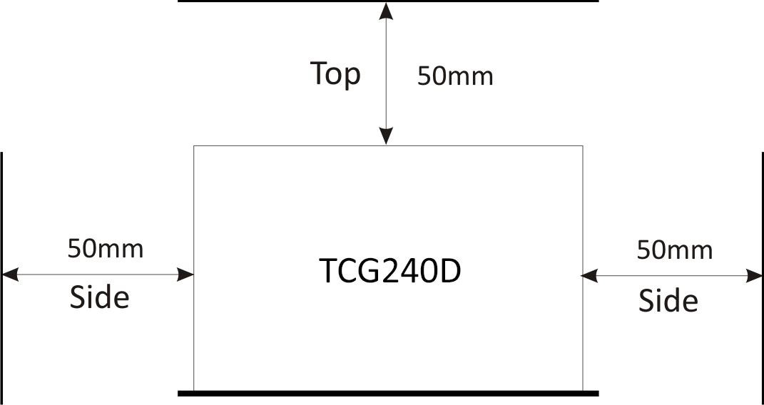

Fig.1

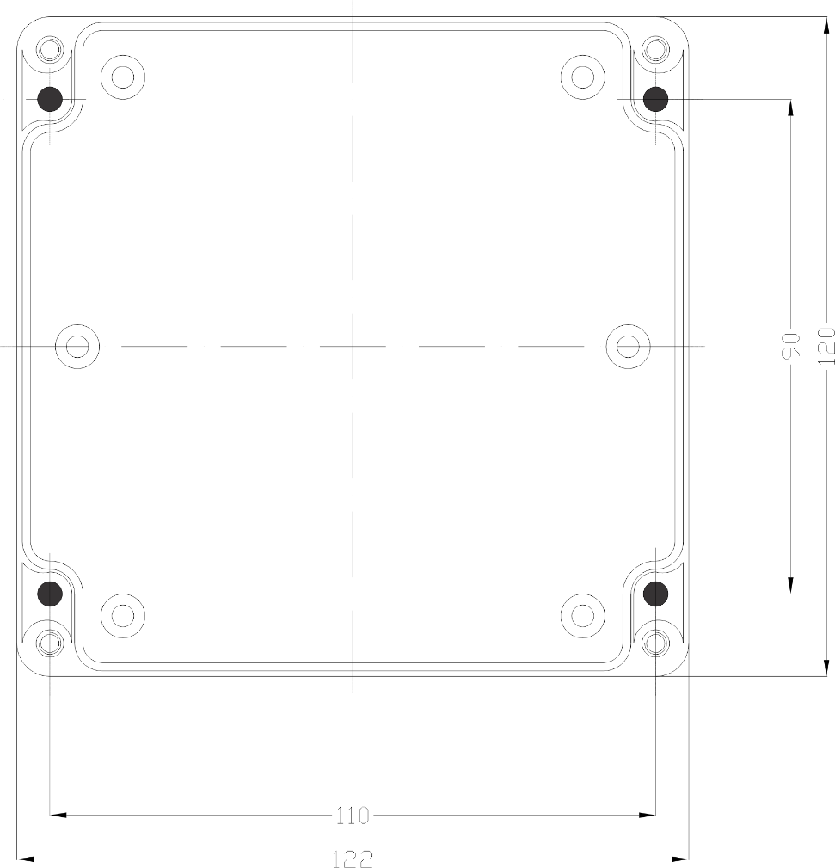

Fig.2

